How to print a transcript from Cornerstone….

Log onto Cornerstone via WebCentral.

When you get to your home page, please click on reports… 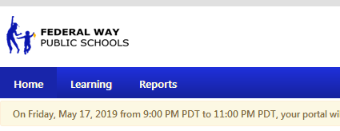

Hover your cursor on Reports and then “Click on Custom Reports”

Once you are in reports you will see the following . Click on Actions, to get the drop down “refresh” (refresh- always do this so the current classes are added to your transcript.)

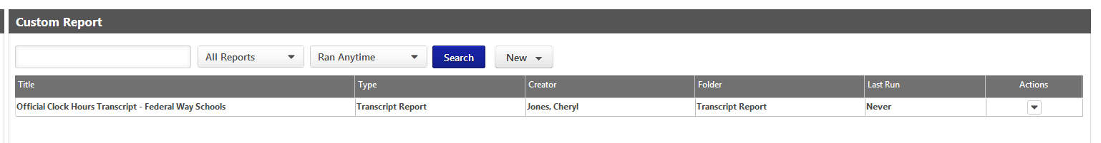

Once you see the Last Run date, click on the Action to get the drop down again… Then click print.
(this will bring up a excel looking spread sheet that has a Title: Official Clock Hours Transcript – Federal Way School District)
Once you see this …. Click on the 3 lines in the top right corner.. 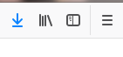 and click.. go down to print… click on print to print your transcript.

Then depending on the browser you are using you might havae to click print again…

If you are looking for a “Official FWPS Transcript”, please contact the CLC and we can print one for you.

