Letter of Agreement
Between
Federal Way Education Association
And
Federal Way Public Schools

The parties agree to the following:
A collaborative team of FWEA members and the District will create a document during the 2018-19 school year that explains the District’s Instructional Materials and Curriculum Policies in detail. The purpose of the document is to clarify which instructional material decisions can be made individually and which must follow a formal approval process. Upon completion, the explanatory document will be shared widely with all FWPS certificated staff.

Effective September 1, 2018 through August 30, 2021.

____________________________________ ____________________
FWEA Date

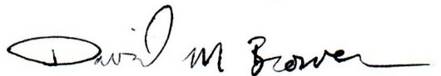
____________________________________ ____________________
For Federal Way Public Schools Date

